Playground lab (RUM)

Go and check the custom app

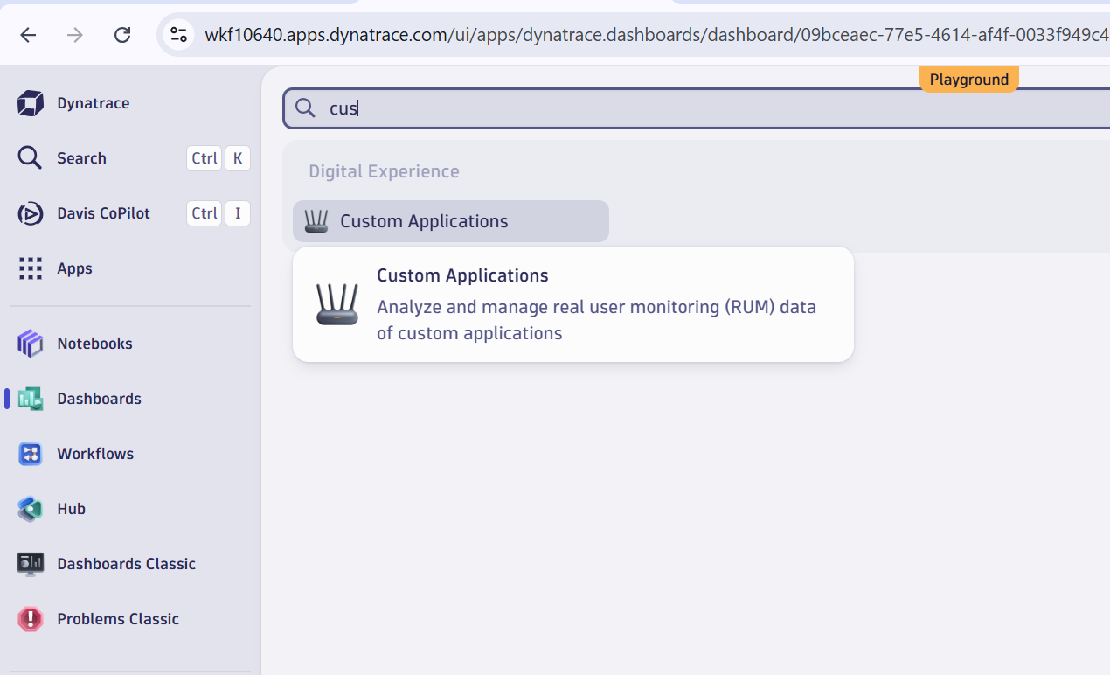

Click on webapp

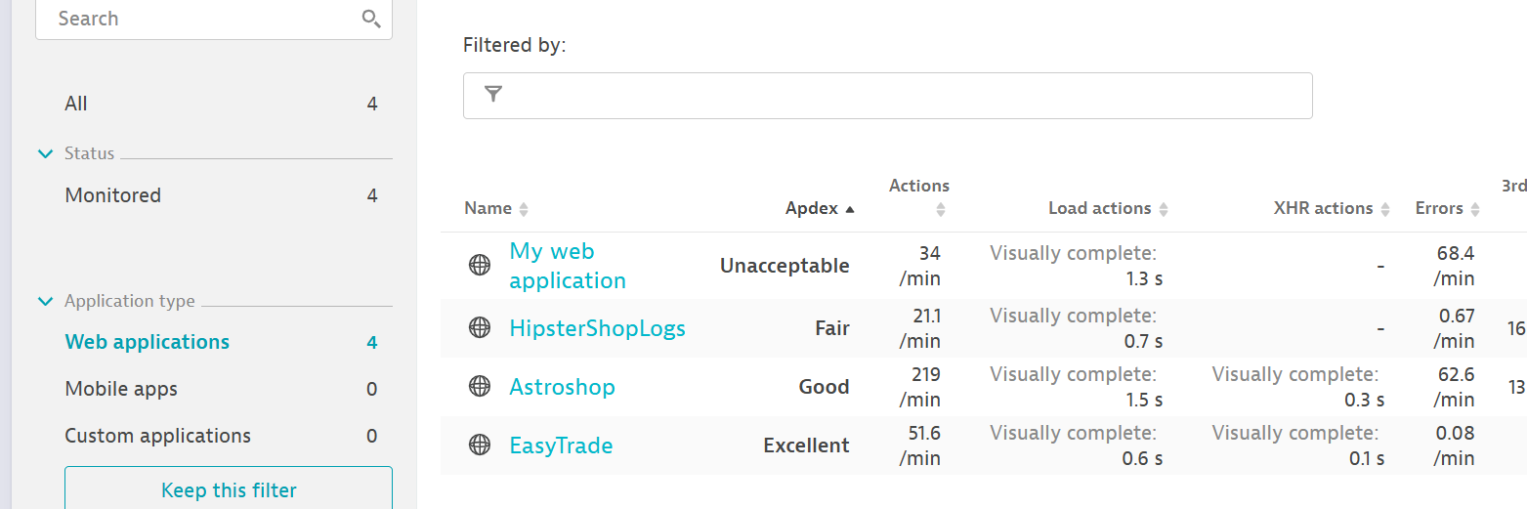

Check HipsterShopLogs



HealthCheck

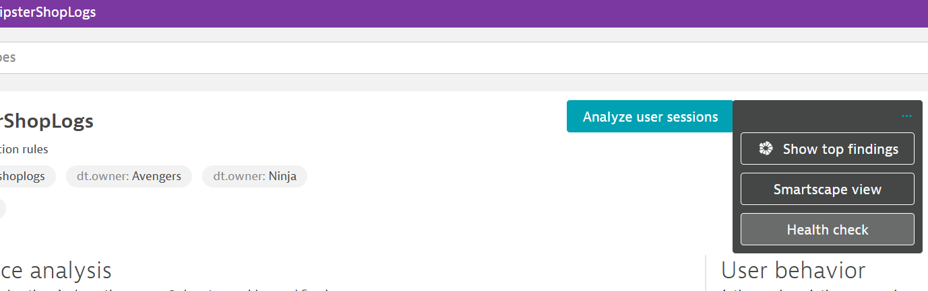

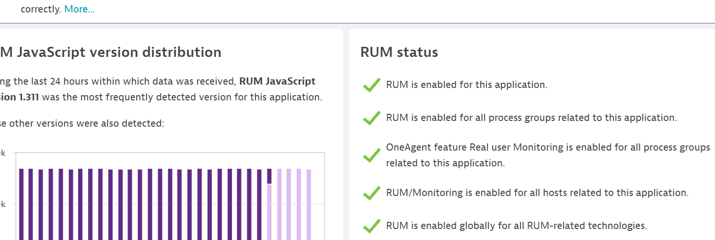

Now I want to check my smartscape view

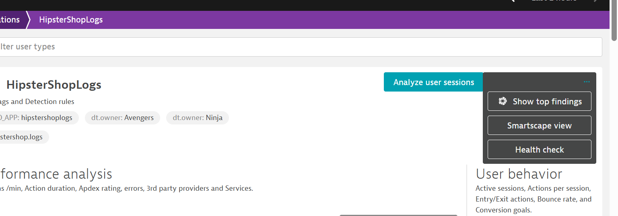

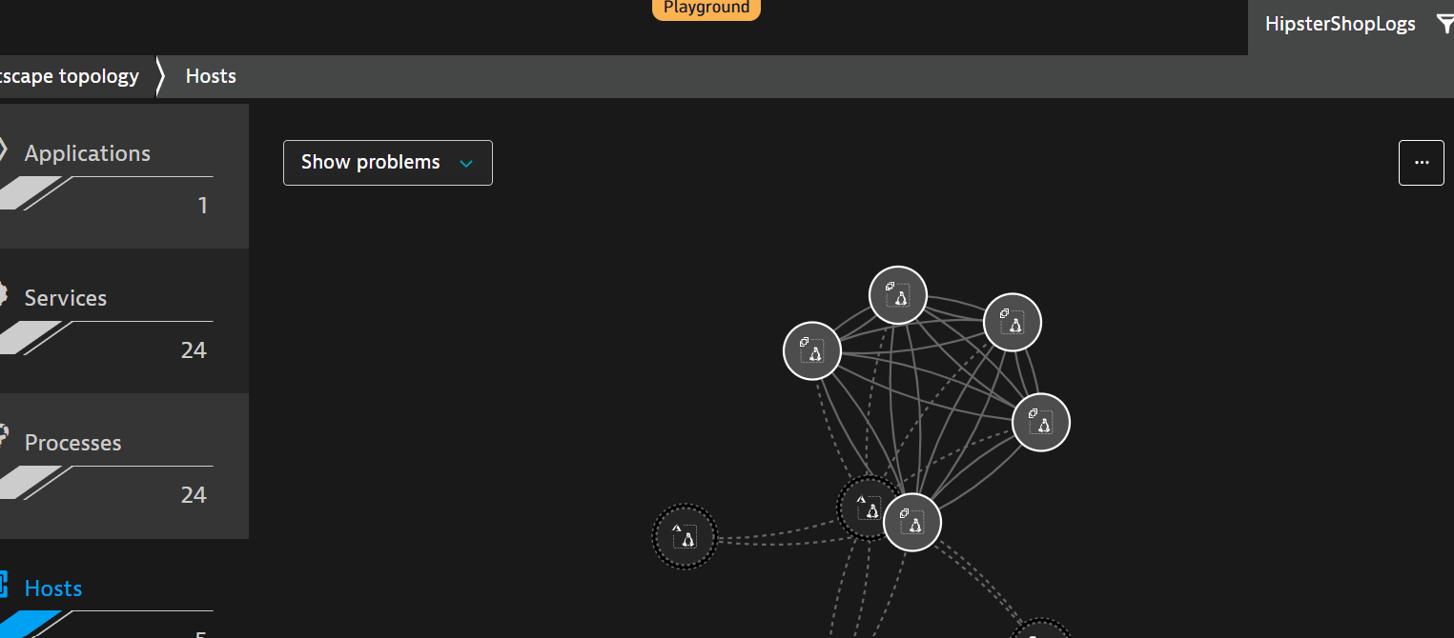

This who calculation(Telemetry) comes through one agent, it usage javascript to get this telemetry

Check the performance analysis, check top broser, real user and geolocation breakdown

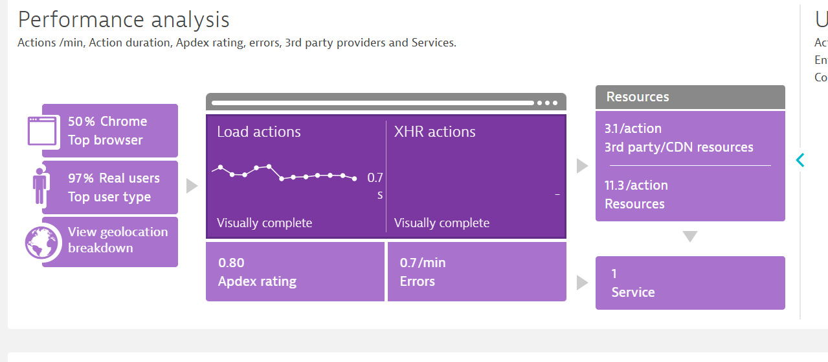

Lets understand what is appdex ration

The Apdex score is a numerical metric that measures user satisfaction with an application's performance, ranging from 0 to 1. A score of 1 indicates all users are satisfied, while 0 means none are satisfied. It's calculated by considering satisfied, tolerating (slightly slower but still usable), and frustrated (unacceptable performance) user requests.

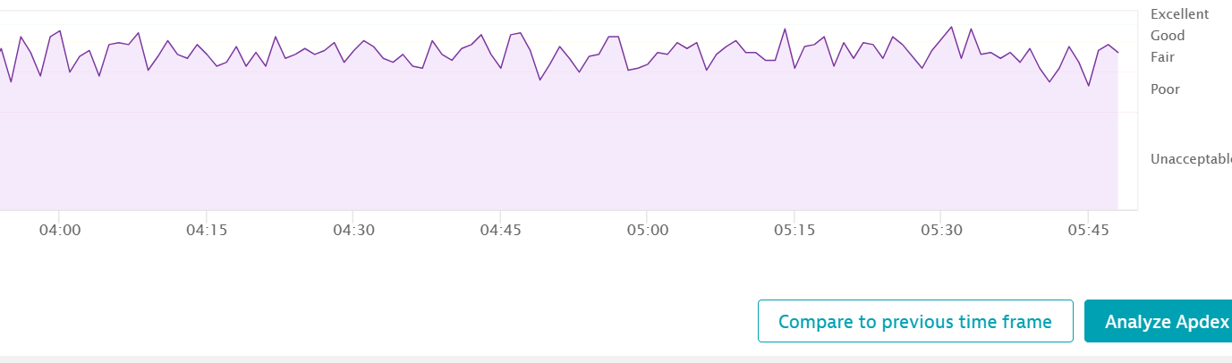

Compare with pervious timeframe

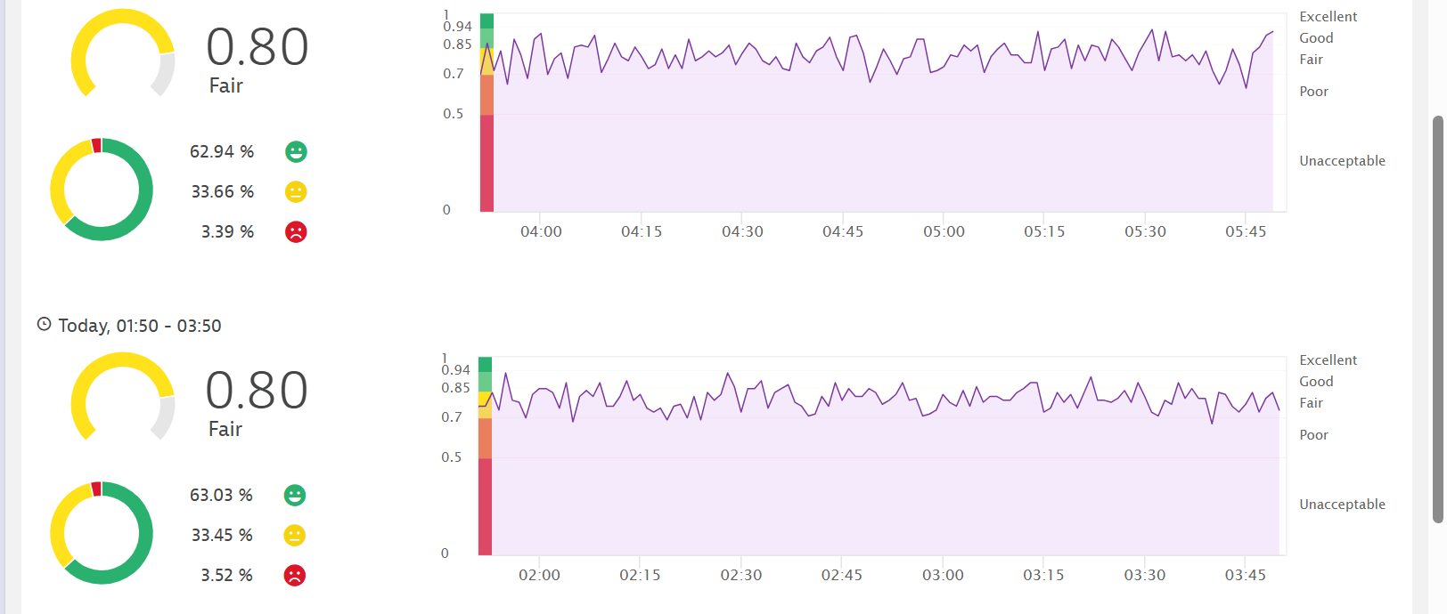

Check appdex in details: To see why rating is average

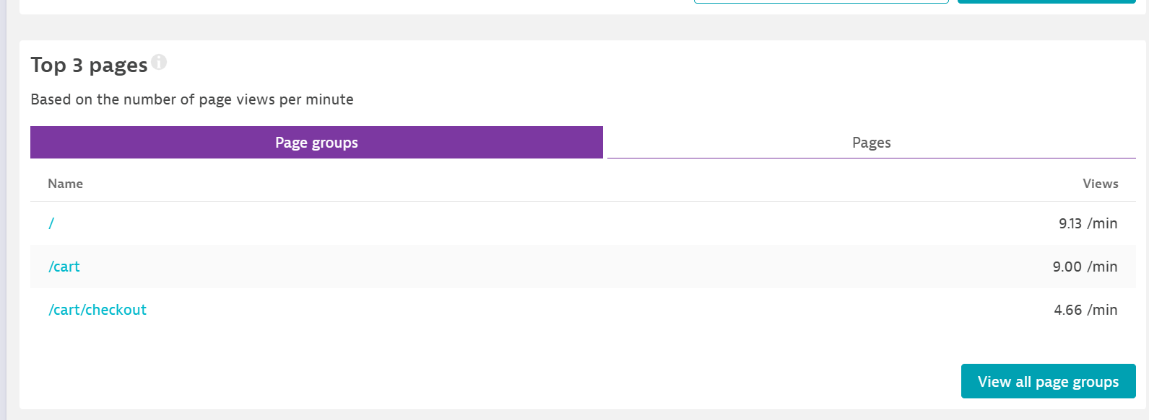

Check waterfall analysis of homepage

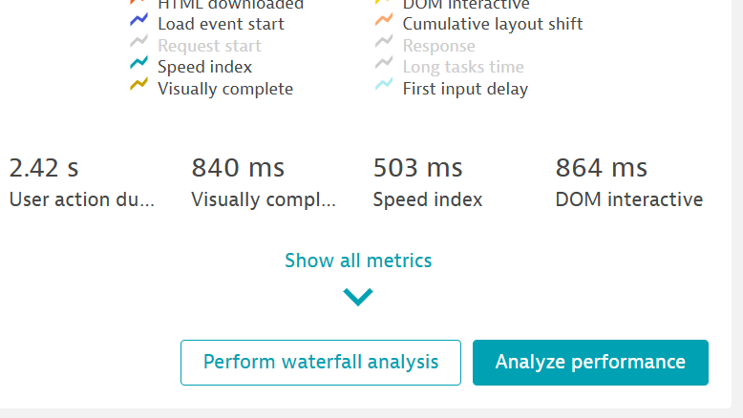

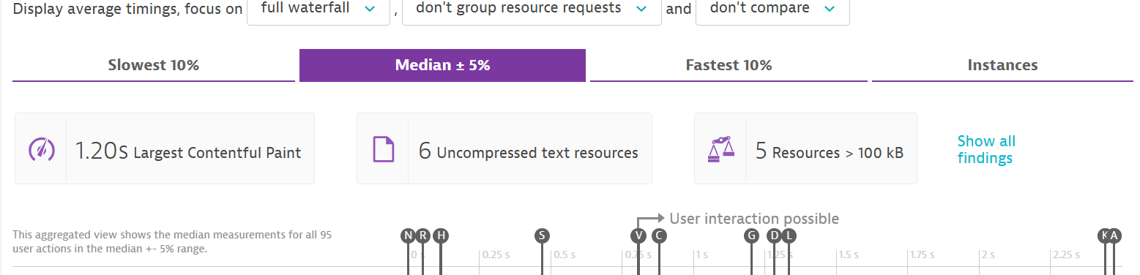

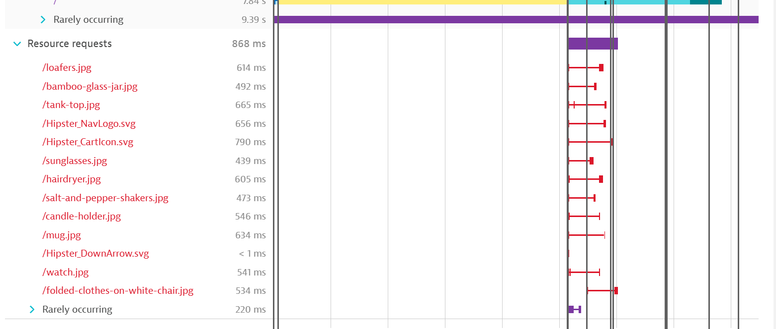

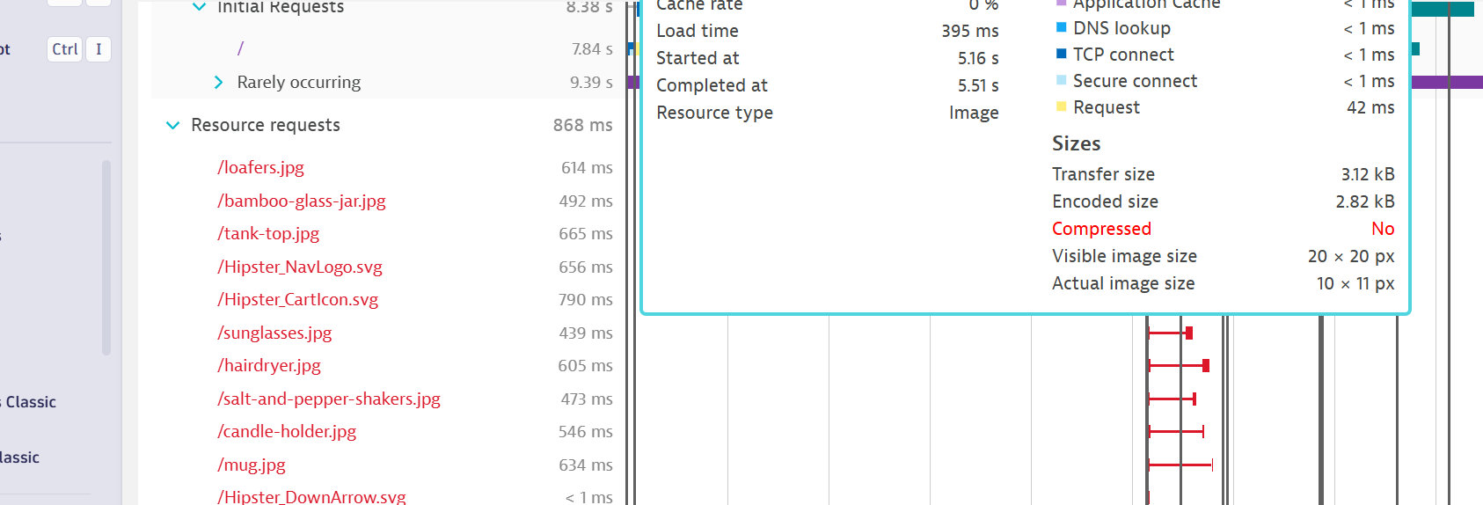

Solution : As SRE ??

Check cart page

